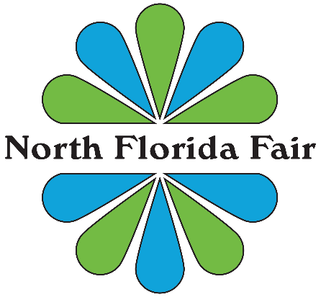

FOR IMMEDIATE RELEASE
North Florida Fair Receives Proclamation Honoring More Than 80 Years of Community Impact
TALLAHASSEE, Fla. — The North Florida Fair was honored today with an official proclamation from Nick Maddox recognizing the organization’s more than 80-year commitment to community engagement, agricultural education, and youth development.
Presented in Leon County, the proclamation acknowledges the North Florida Fair’s longstanding role in promoting agriculture, supporting educational opportunities for young people, and bringing the community together through one of the region’s most recognized annual traditions.
For more than eight decades, the Fair has served as a cornerstone event for Tallahassee and the surrounding region, welcoming more than 125,000 visitors each year while providing opportunities for youth through livestock exhibitions, educational programming, and scholarship initiatives.
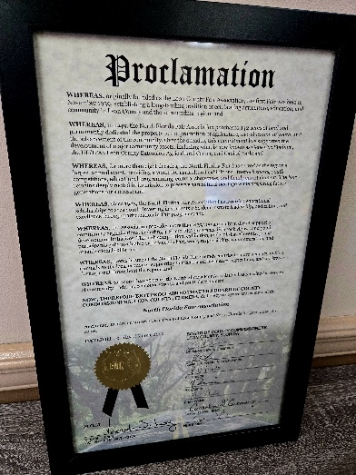
“This recognition reflects the dedication of generations of volunteers, exhibitors, educators, and community partners who have helped build the North Florida Fair into what it is today,” said representatives of the Fair. “Our mission has always centered on promoting agriculture and educating young people, and we are proud to continue that work for our community.”
The proclamation highlights the Fair’s lasting contributions to strengthening the local agricultural community, supporting youth development through programs such as 4-H and FFA, and preserving the agricultural heritage of North Florida.
As the Fair looks toward the future, its leadership remains committed to expanding opportunities for young exhibitors, enhancing educational programming, and continuing its mission of serving as a place where agriculture, education, and community come together.
###

